

**Module Code & Module Title**

**CC4057NI Introduction to Information Systems**

**Assessment Weightage & Type**

**30% Individual Coursework**

**Year and Semester**

**2021-22 Autumn**

**Student Name:ROCHAK LAMA**

**Group:C9**

**London Met ID: 21049576**

**College ID: np01cp4a210234**

**Assignment Due Date:**

**Assignment Submission Date:**

*I confirm that I understand my coursework needs to be submitted online via Google Classroom under the relevant module page before the deadline in order for my assignment to be accepted and marked. I am fully aware that late submissions will be treated as non-submission and a marks of zero will be awarded.*

# Table Of Contents

# List Of Figures

# List Of Tables

# INTRODUCTION

Technological improvements are created every day. In recent years, the internet has taken over the world. In addition, the internet has become the cornerstone for everything we do these days. Everything, even music, is available on the internet. Movies, gambling, commerce, finance, and a variety of other activities are just a few examples. You can find anything on the internet. Similarly, there are numerous websites on the internet that offer books. They make an effort to make their website appealing in order to attract customers and ensure that they purchase from it.

As stated in the coursework, we must develop a five-page website that sells books online. The first homepage of our website is Home, which contains information about our website. It is also the initial webpage of our website. The second option is Featured Books, which provides a list of books along with their cost and title. The third is a blog with the topic of How Technology Has Affected Our Everyday Lives. The fourth section is Contact, where you can contact us by filling out visitor information. The last page is the research page, which should include a comparison of our website to five different web pages. Our website should have an uniform look and feel, as well as proper navigation that allows us to explore each part.

The coursework's goals and objectives are to teach us how a website is built and what factors are crucial to consider while developing a well-managed and appealing website. After completing the coursework, we will be able to create a visually appealing website. The ability to create a basic and appealing website will be acquired.

The website was built and designed using HTML5, CSS3, and JavaScript. HTML was used to construct the website's basic design. HTML components such as title, meta, picture, table, div, form, and others were used. CSS was used to create the wording, graphics, and colors. CSS was utilized to make the website more appealing. CSS was mostly used to style the website. Internally, inline, and externally, CSS was employed. CSS was used as well, with a variety of tags and properties. JavaScript was used to make the website responsive. JavaScript is used to make the website more interactive for the user. JavaScript was used to change the structure of the website on the fly.



*Figure 1 HTML*



*Figure 2 CSS*

**

*Figure 3 JAVA*

# Discussion and Analysis

1. **Text editor used to develop the website:**

For my coursework, I used Visual Studio code to construct HTML, CSS, and JavaScript. Visual Studio Code is a free coding suite for Windows, Linux, and macOS from Microsoft. This text editor was picked since it has a lot of features that make coding easier and quicker. It's easy to use and completely free. Visual Studio Code is quite popular among programmers. Java, JavaScript, Python, Node.js, C++, and other programming languages are supported by Visual Studio Code.



*Figure 4 Visual Studio Code*

1. **Wireframe Used:**

Balsamiq Wireframes were used to construct the wireframes for my website. Balsamiq wireframes is a Balsamiq Studios software for Windows and macOS. It's a piece of software that's solely for the purpose of developing wireframes. It's quite user-friendly, and it includes all of the tools we'll need to create our website's layout or design. It includes with ready-to-use tools and icons for creating wireframes.



*Figure 5 Balsmiq*

1. **Website:**
2. Home page

To separate the website into three pieces, I utilized the header, section, and footer tags on the main page. The header section has a navigation bar that links to all pages, a text area below the navigation bar on the left side, and an image on the right side. Cosmos+white color scheme with radial gradient backdrop is used in the header. A little introduction is given in section portion below which is a button named explore that is changed using css and sends you straight to the top. Some social media icons can be found in the footer section.

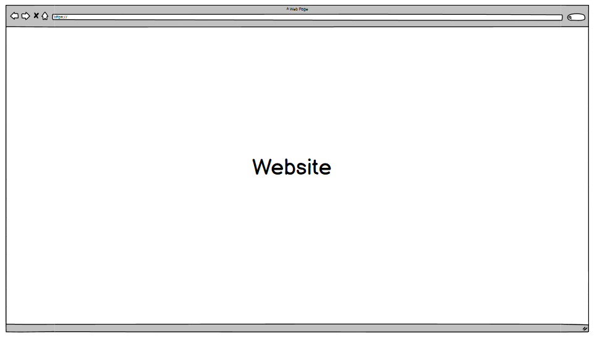

*Figure 6 Website*

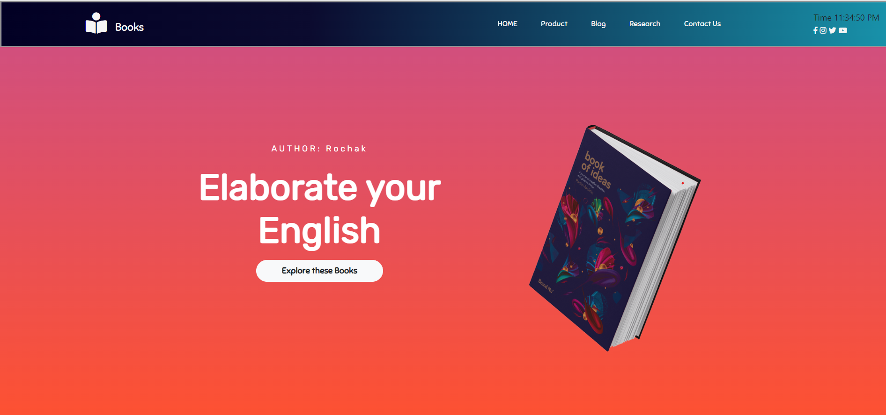

*Figure 7 Webpage*

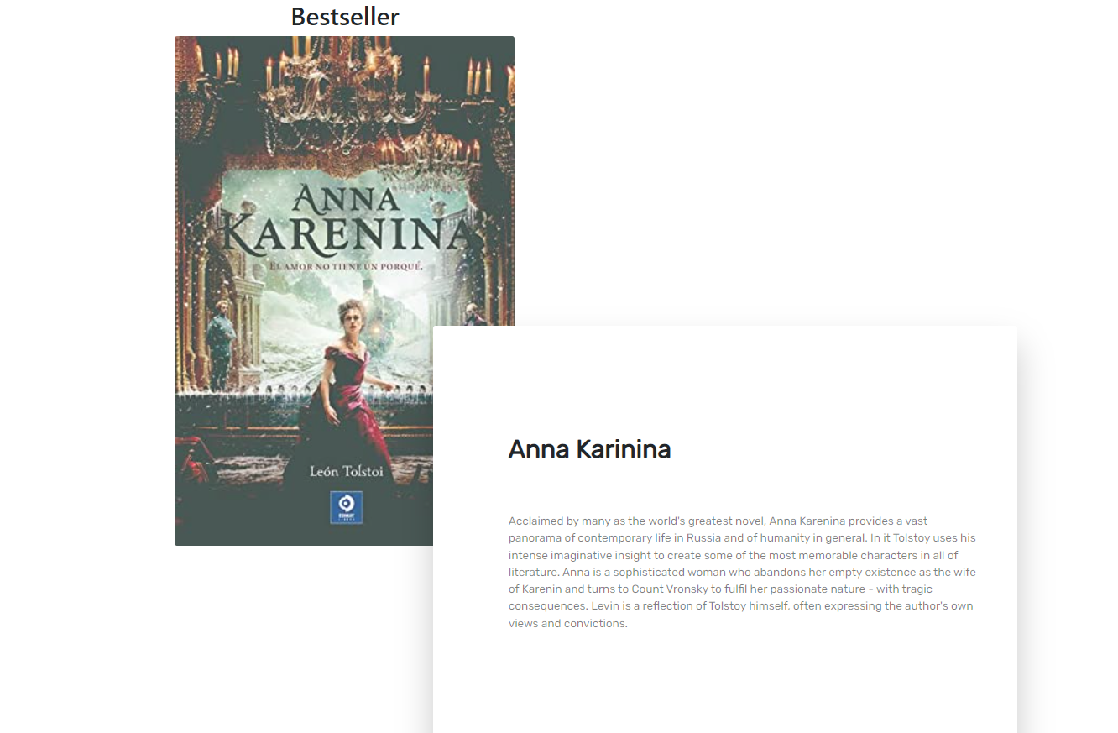

*Figure 8 Webpage Book*

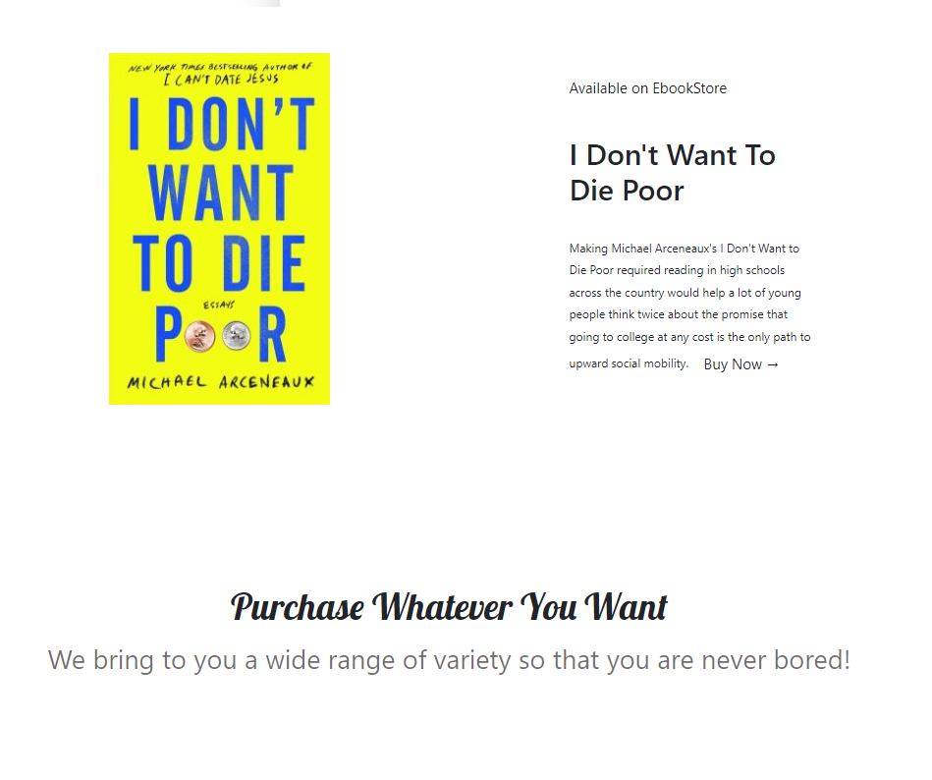

*Figure 9 webage product*

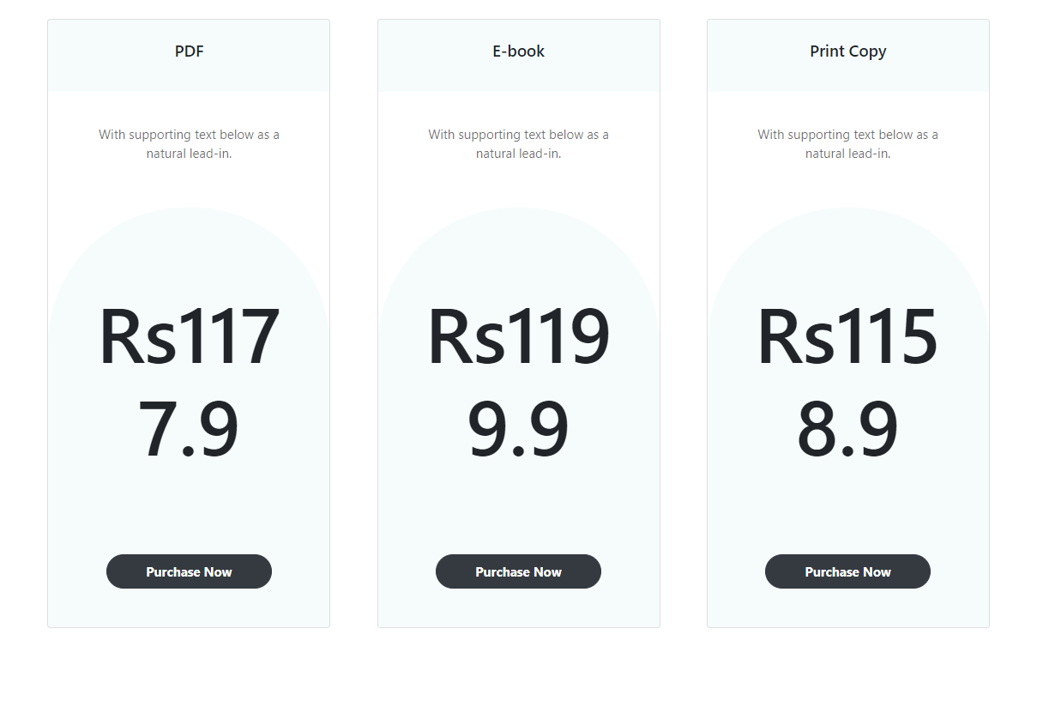

*Figure 10 Webpage pdf ebook*

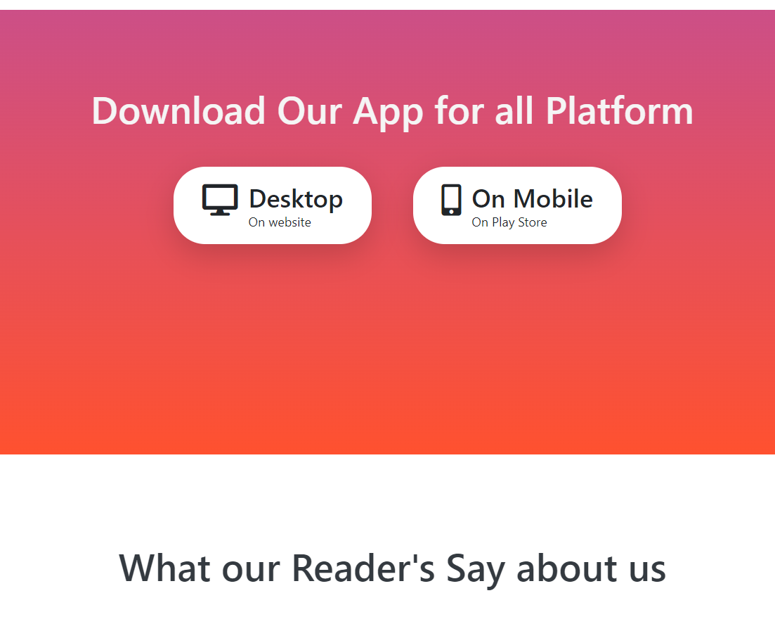

*Figure 11 Webpage ebook download*

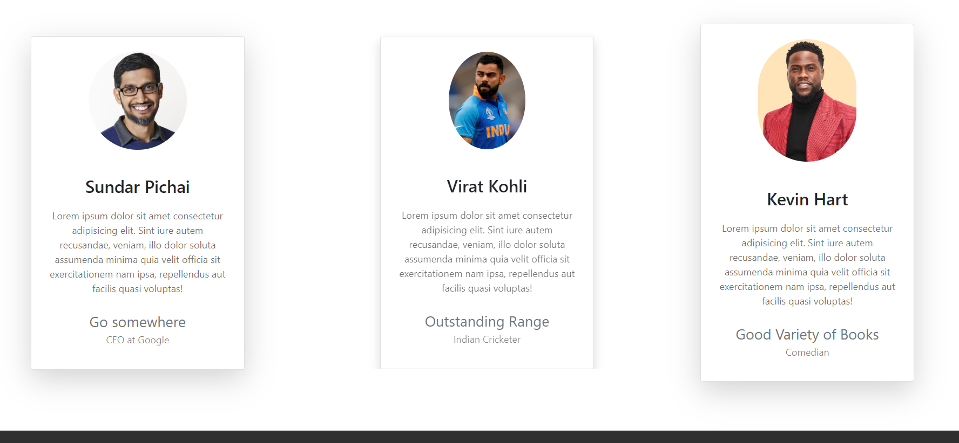

*Figure 12 Webpage Feedback*

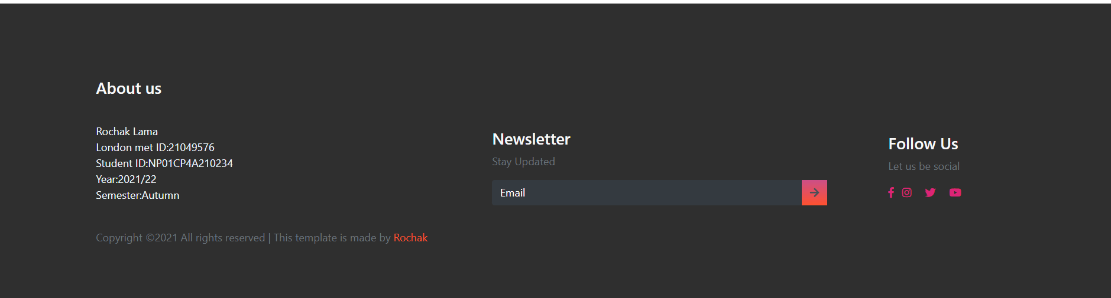

*Figure 13 Webpage About Us*

1. **Featured Books:**

The upper right corner of the page has a navigation bar. I've built a div with the heading "Featured Books." The image of the book, together with its name and price, is then presented in another div. In the same div, an add to cart button is included, which is required if website visitors want to purchase any books. The same procedure is followed for the next nine novels in a row. The wireframe and screenshot of the featured books webpage are shown below.

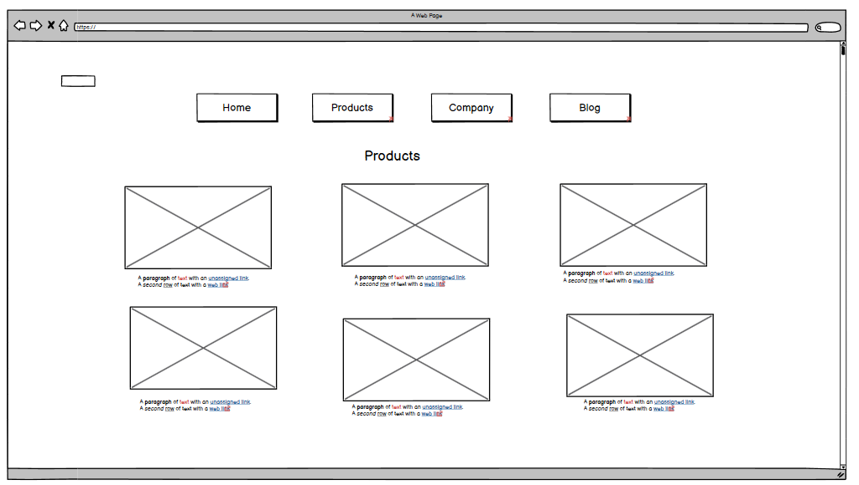

*Figure 14 Product*

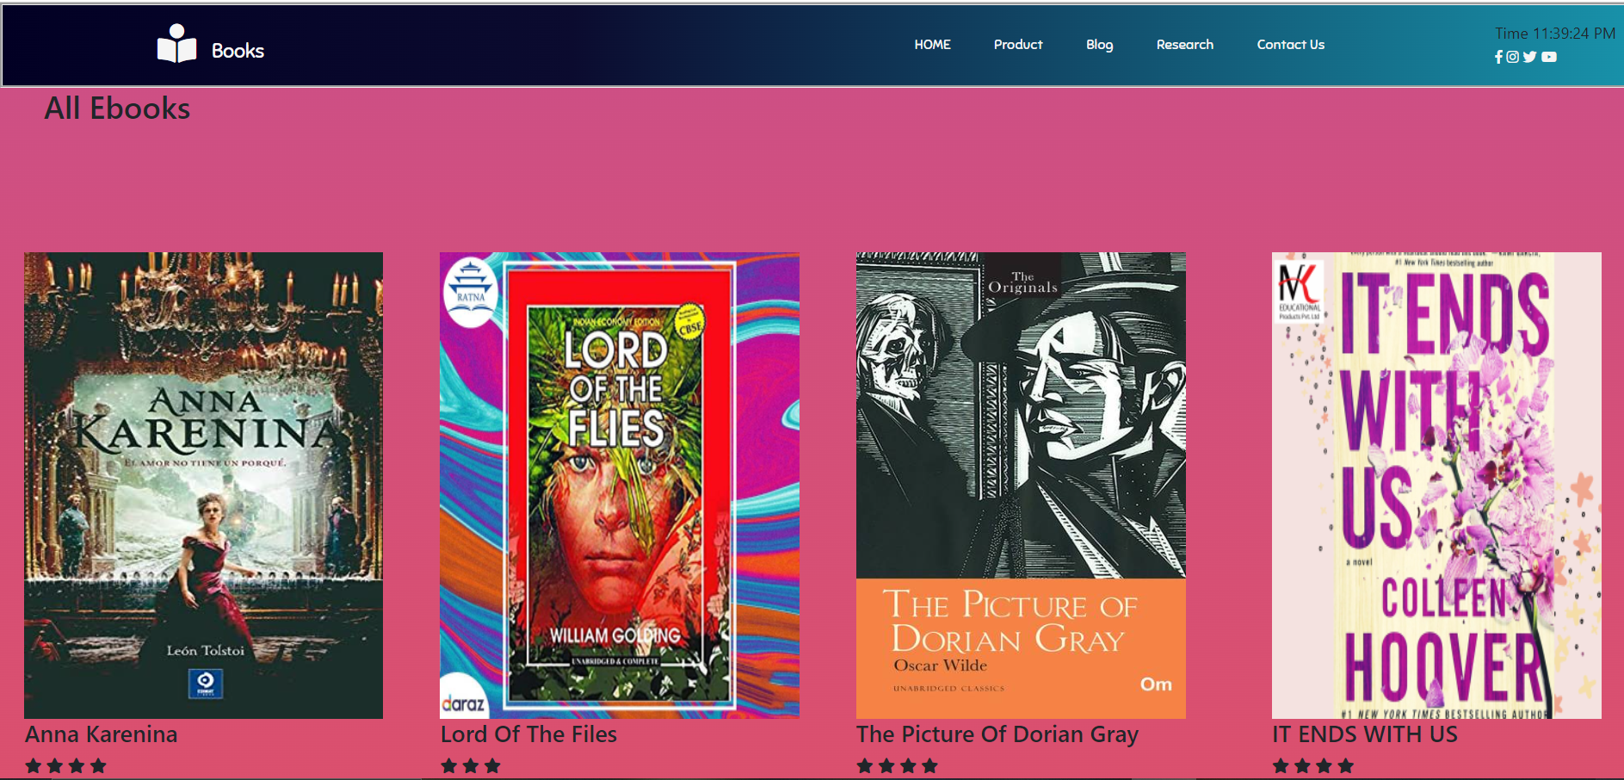

*Figure 15 Product 1 to 4*

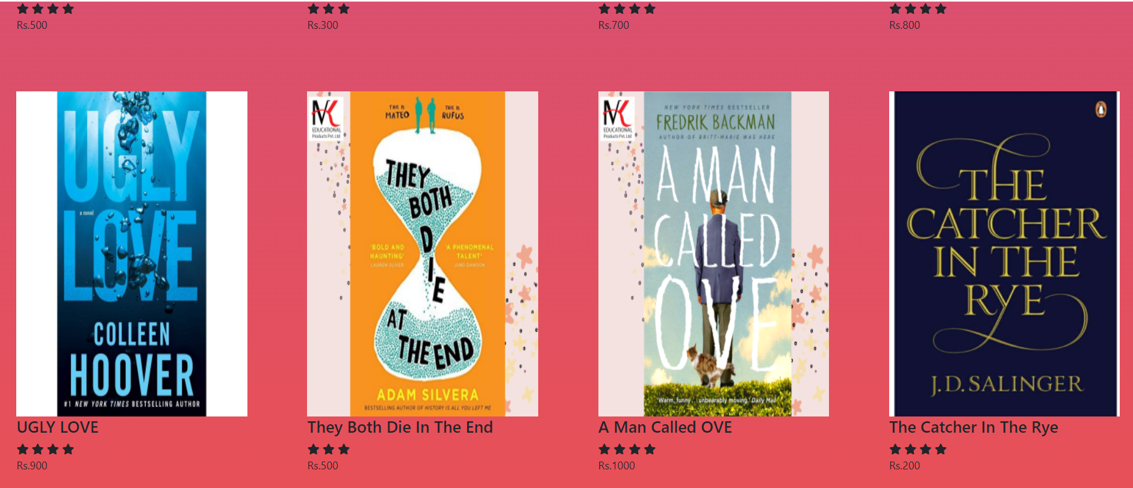

*Figure 16 Product 4 to 6*

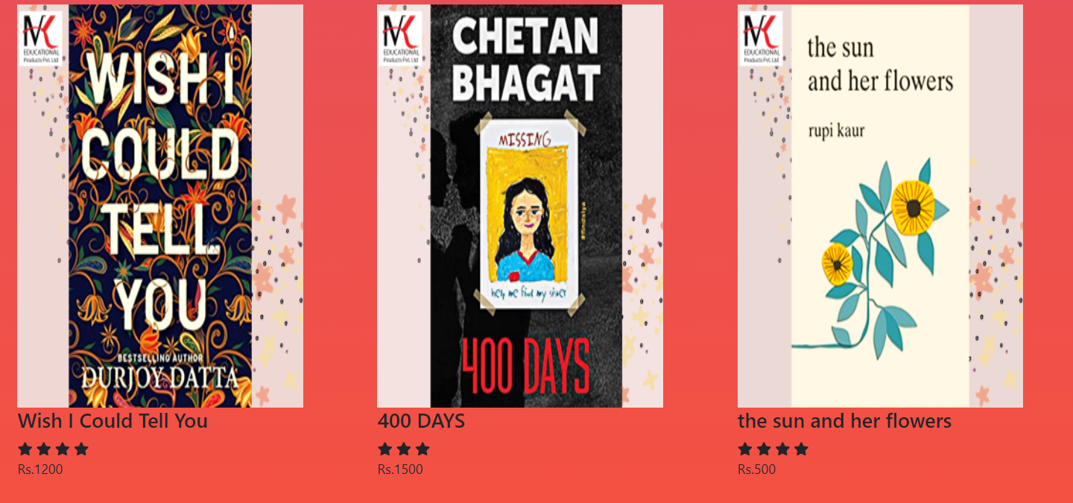

*Figure 17 Product 6 to 9*

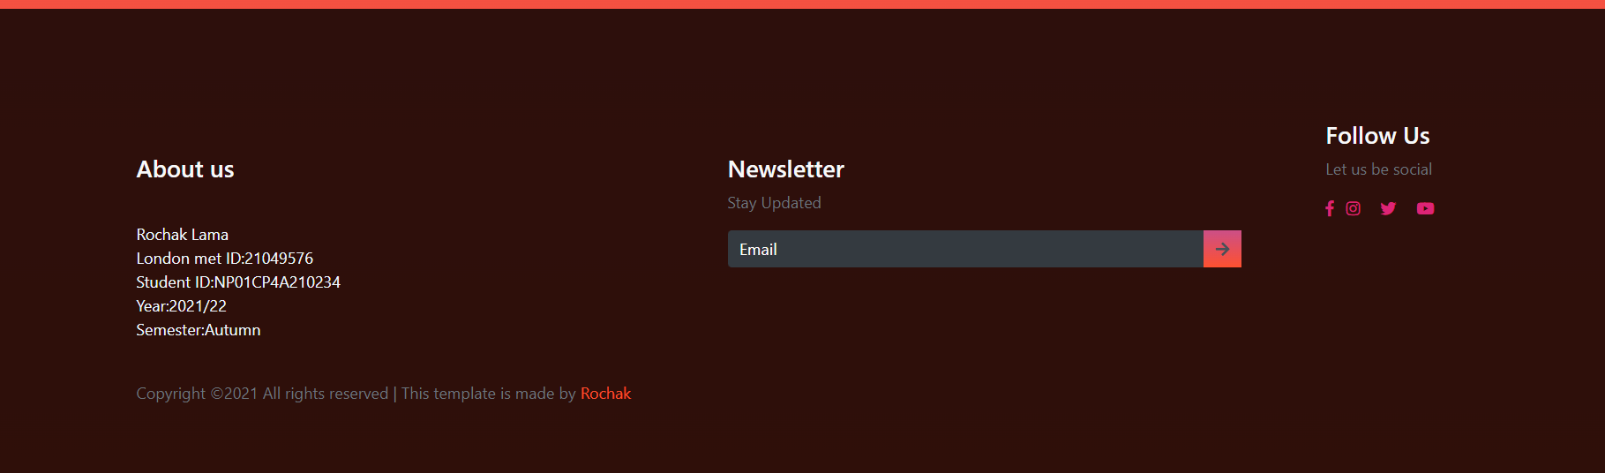

*Figure 18 Product About Us*

1. **Blog Page:**

The upper right corner of the page has a navigation bar. The h1 tag is used to write the topic name of the blog material on the blogs page. A horizontal line is used to provide a boundary between the topic and the content for which the hr tag is applied. To distinguish between positive and negative affects, a table tag with border type 2 and a width of 100 percent is employed. Padding of 10px is used to correctly adapt the table's inner content. Within the paragraph or p tag, the general content is written.

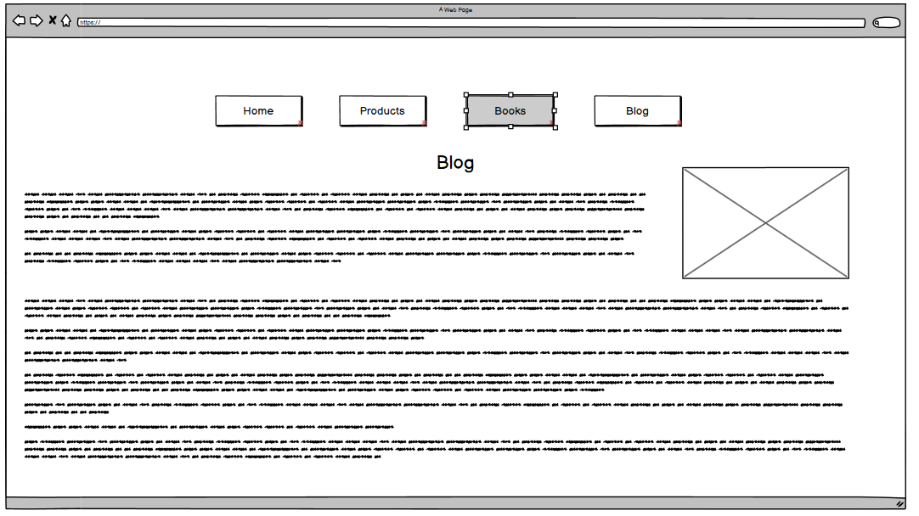

*Figure 19 Blog*

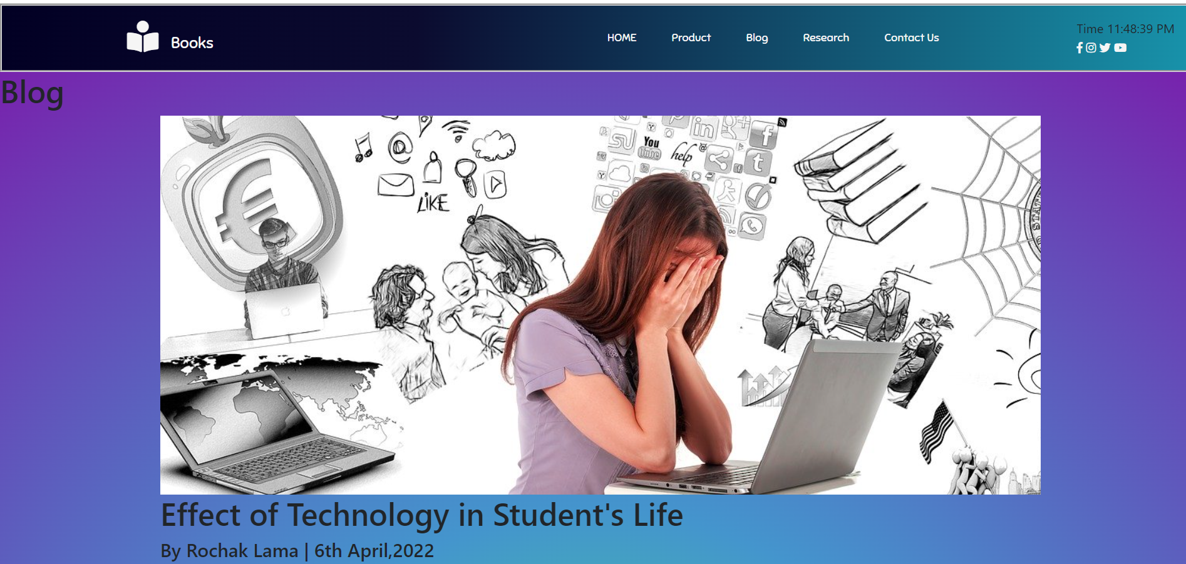

*Figure 20 Blog Page*

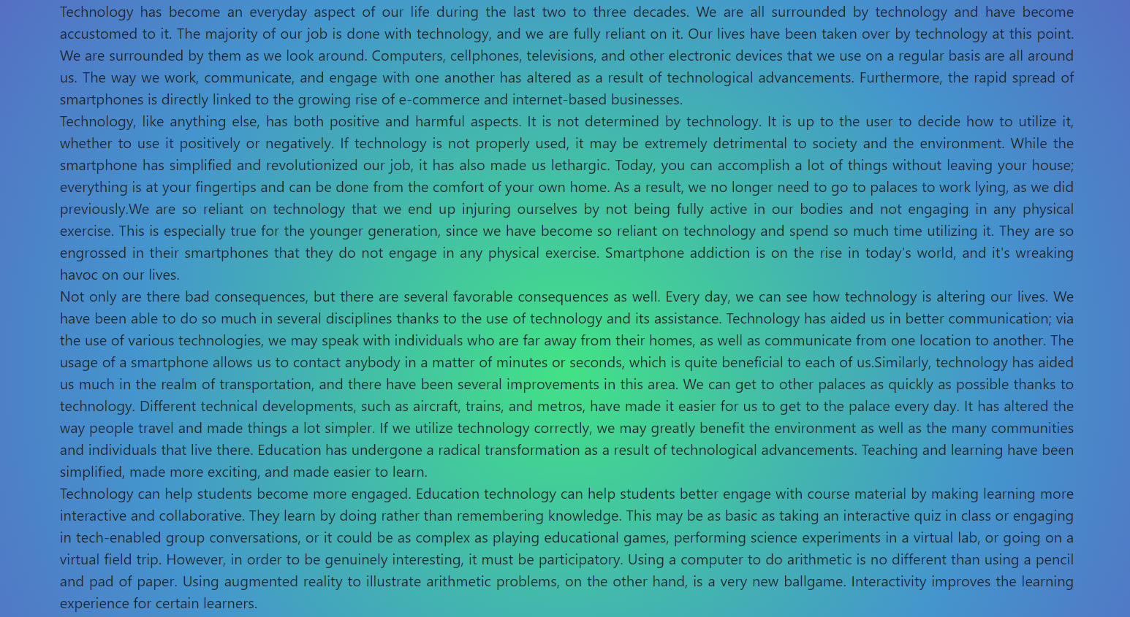

*Figure 21 Blog 2*

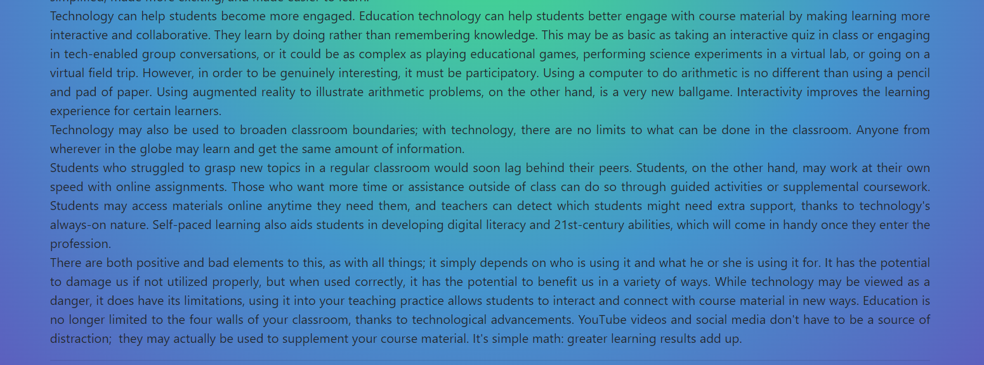

*Figure 22 Blog 3*

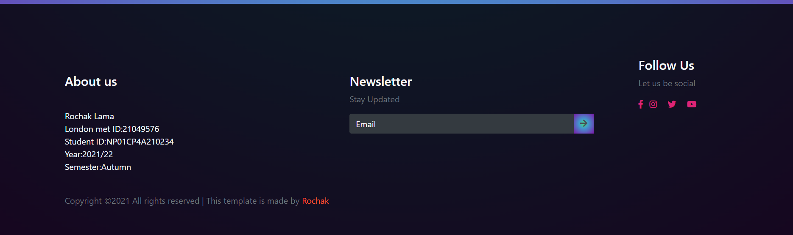

*Figure 23 Blog About Us*

1. **Research**

The cosmic colour backdrop and navigation bar are inserted similarly to previous pages. The creator's name is written at the top, along with the research page, and photographs of the studied web page and my web page are placed. To change the comparison photos, a toggle button called change is included. JavaScript is used to add the toggle function. Descriptions of the pages are posted beneath the photographs. The same is done for five more web pages that have been researched.

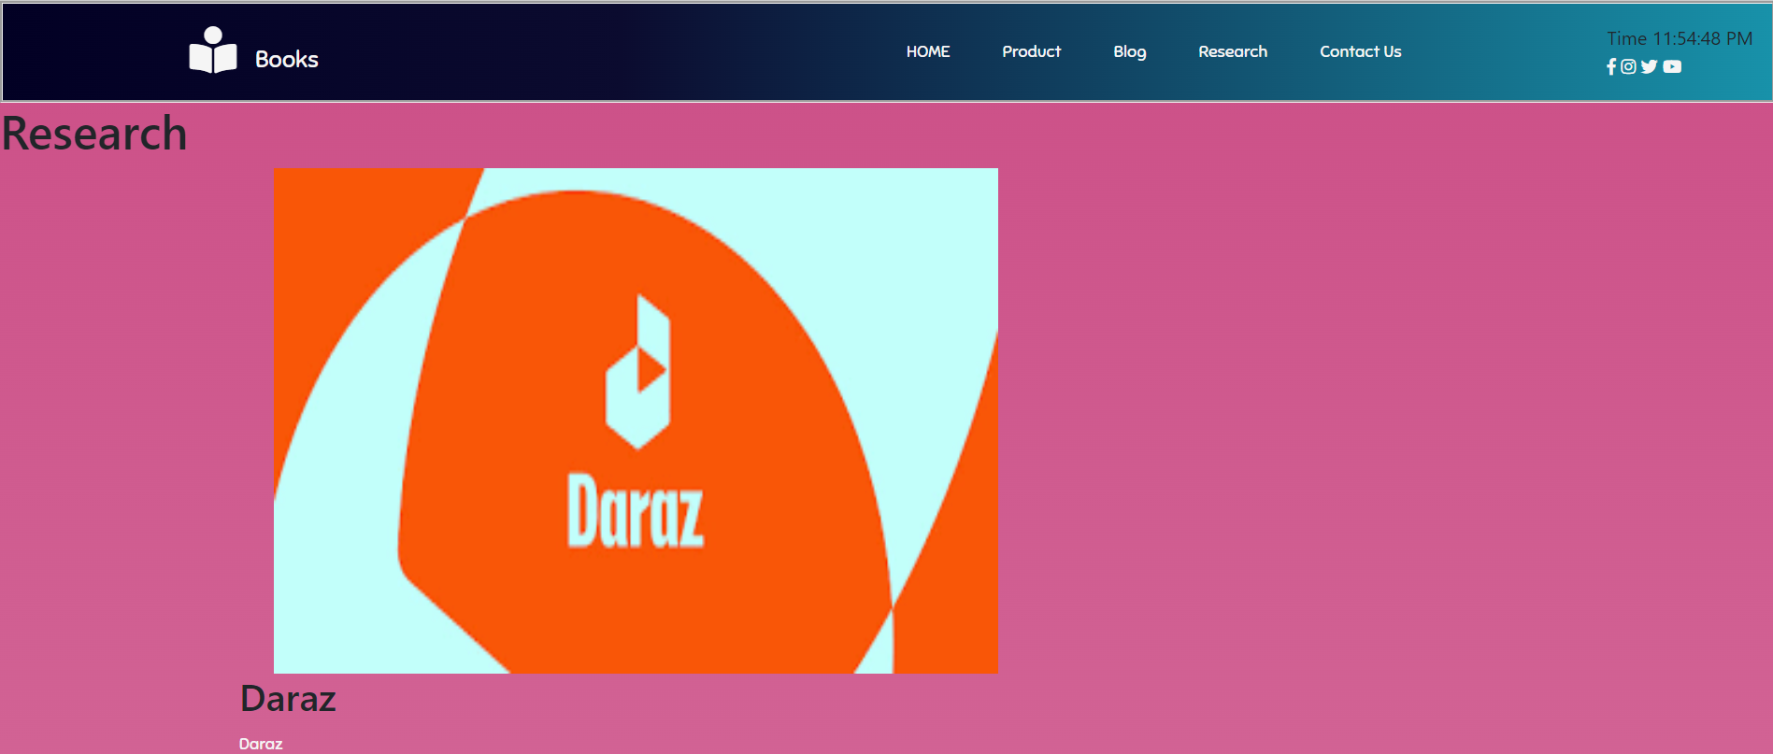

*Figure 24 Research Daraz*

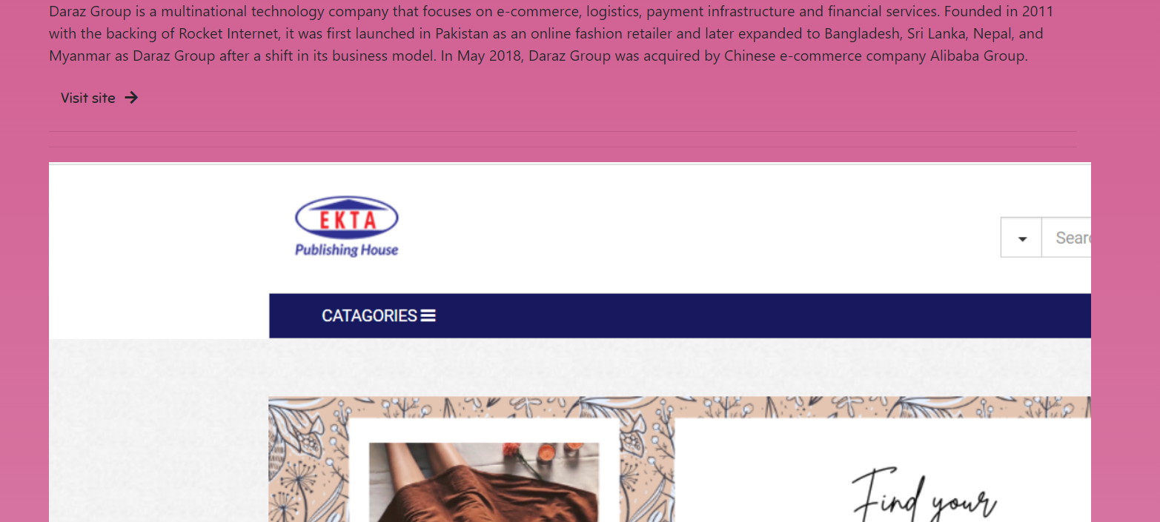

*Figure 25 Research ekta*

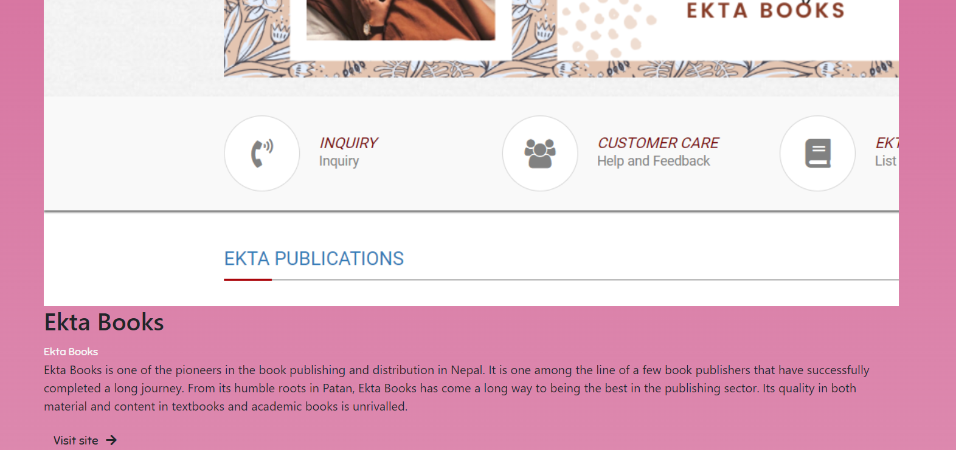

*Figure 26 Research ekta 2*

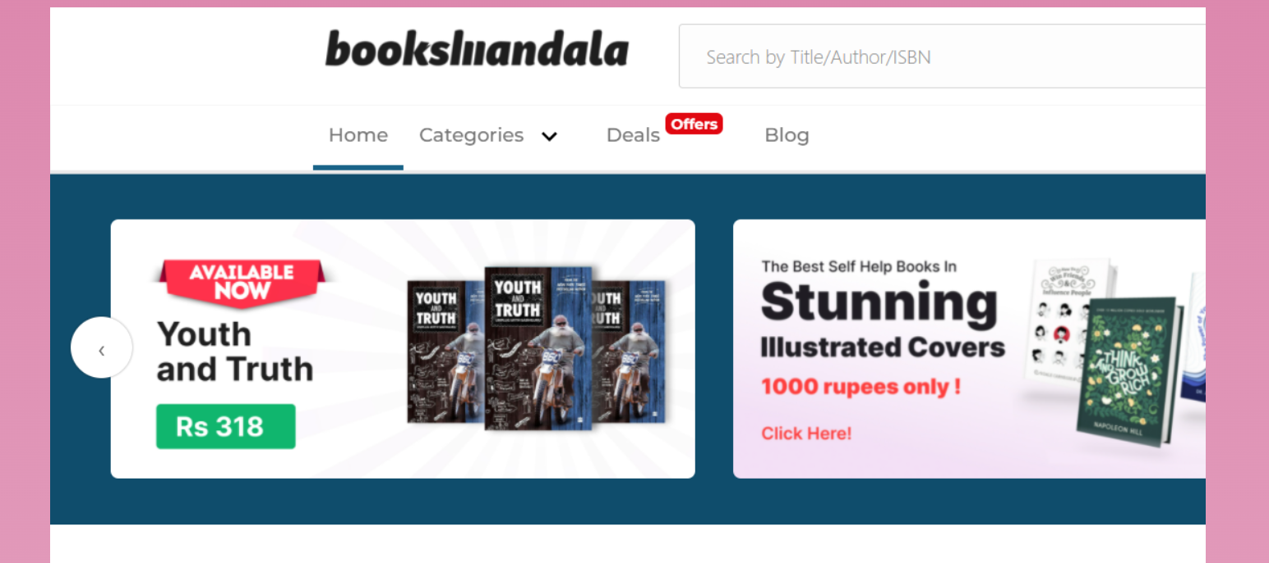

*Figure 27 BooksMandala*

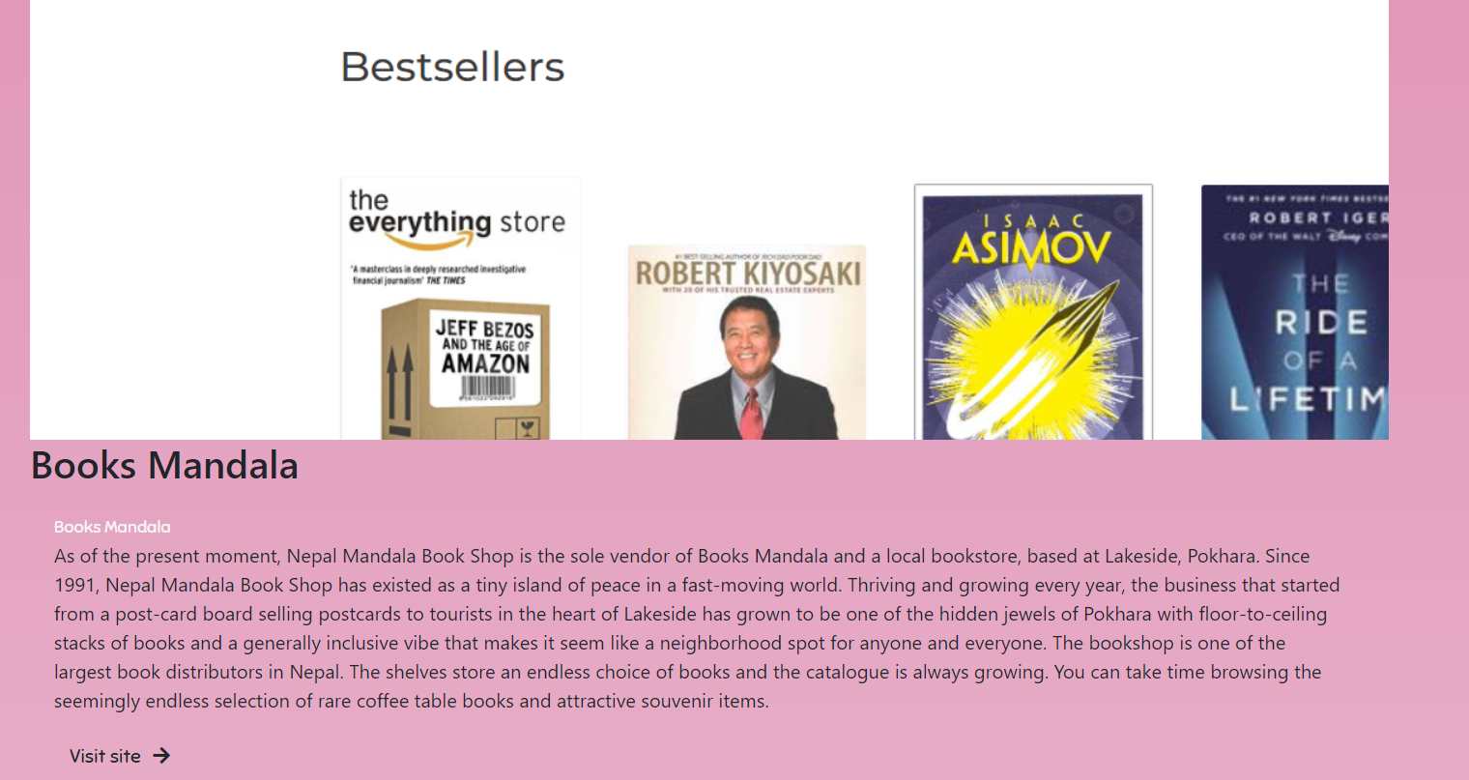

*Figure 28 BooksMandala 2*

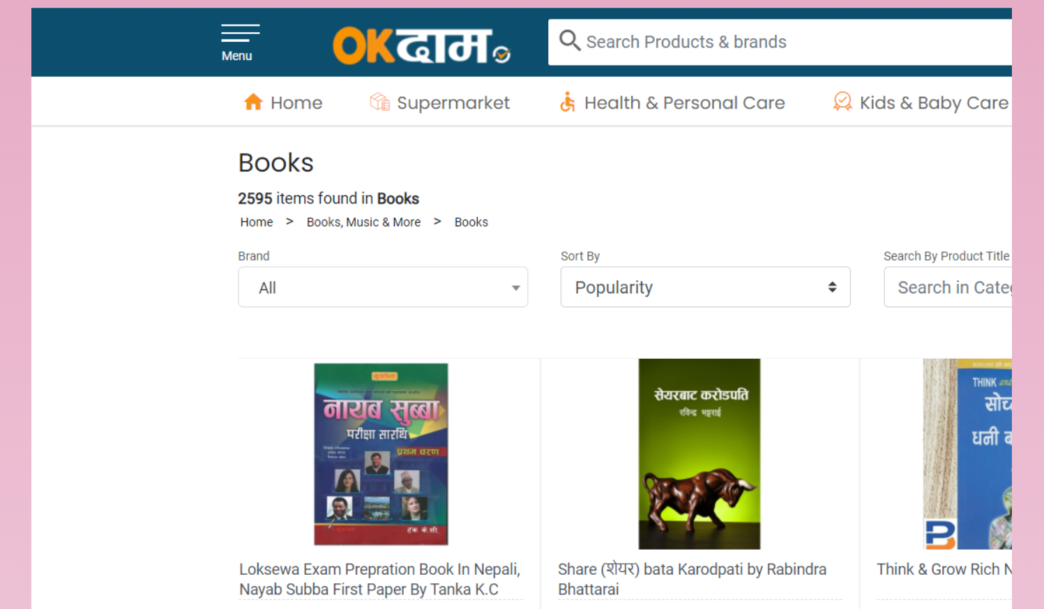

*Figure 29 OK Dam*

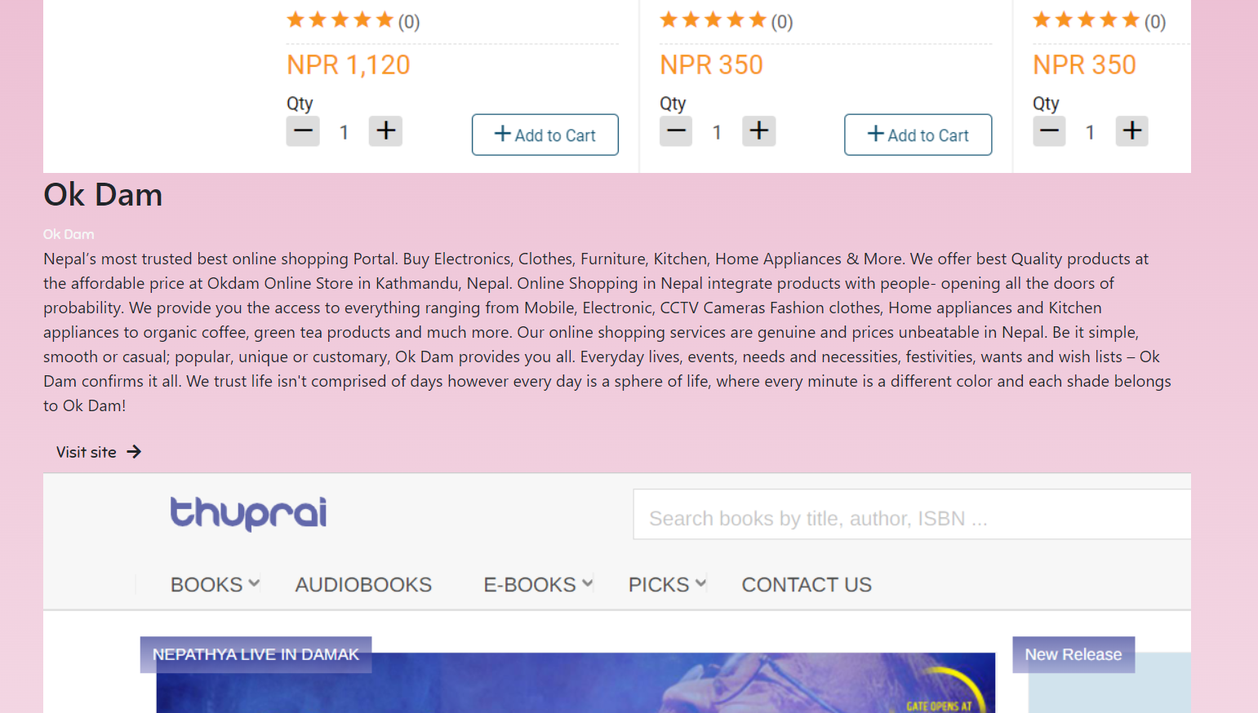

*Figure 30 Thuprai*

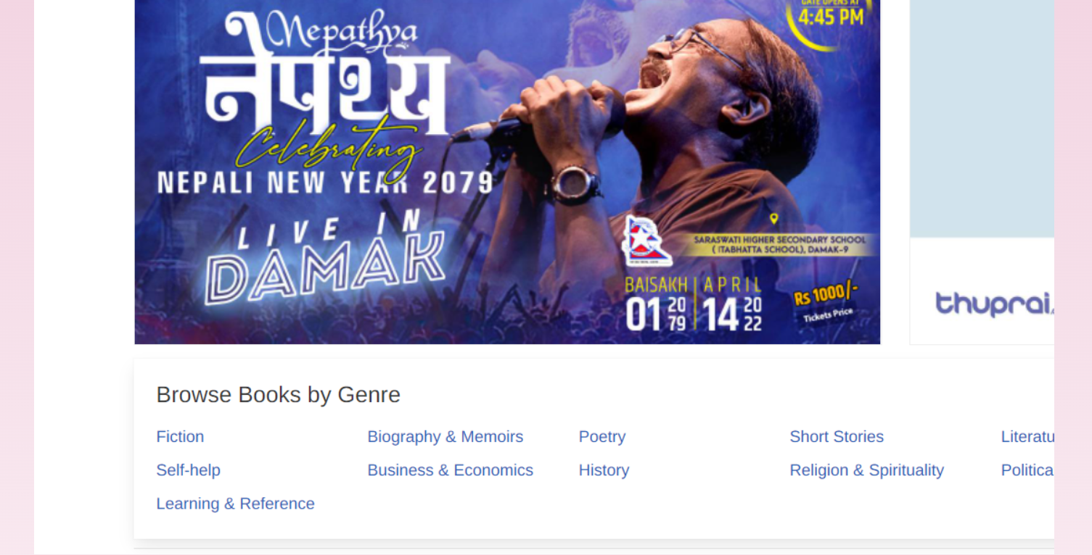

*Figure 31 Thuprai 2*

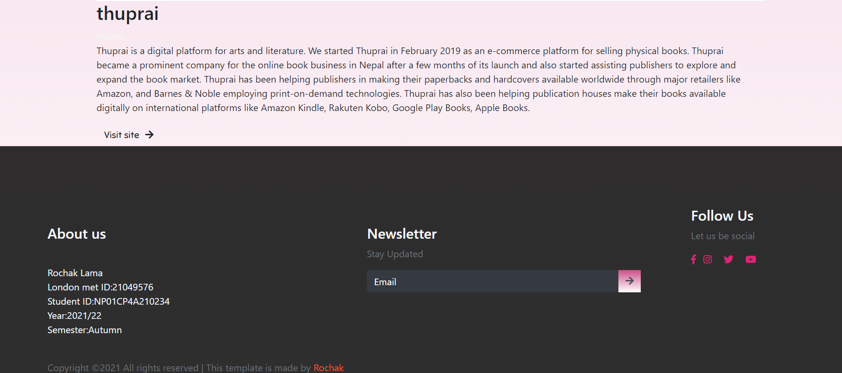

*Figure 32 Research about Us*

1. **Contact Page:**

The contact page uses the same cosmic color backdrop and navigation bar as the other pages. On the right side of the website, there is a form. First Name, Last Name, Phone Number, E-mail Address, and Message are the five input text boxes on the form. A submit button is located at the bottom of the form to submit the form, which has been styled with CSS. JavaScript is used to make the form responsive. A heading is used on the left side, and a link to my social media accounts, together with an icon, is included.

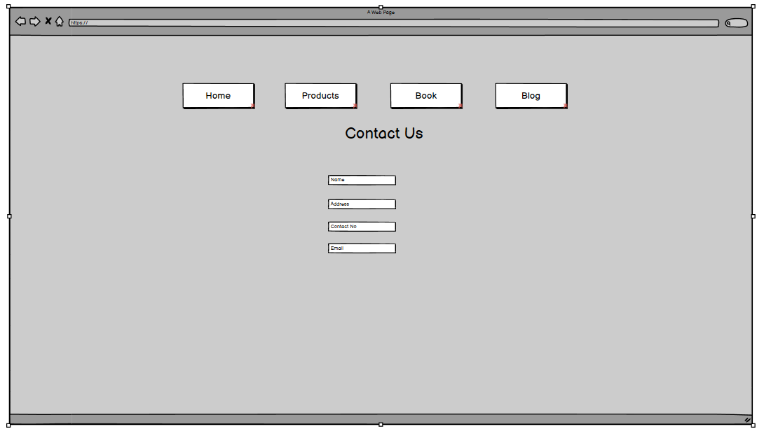

*Figure 33 Contact us webpage*

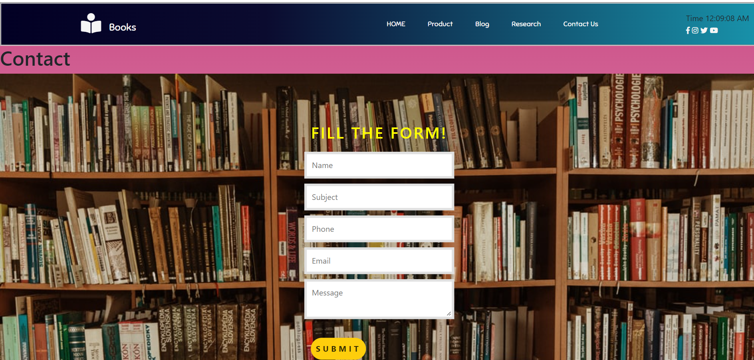

*Figure 34 Contact Webpage Form*

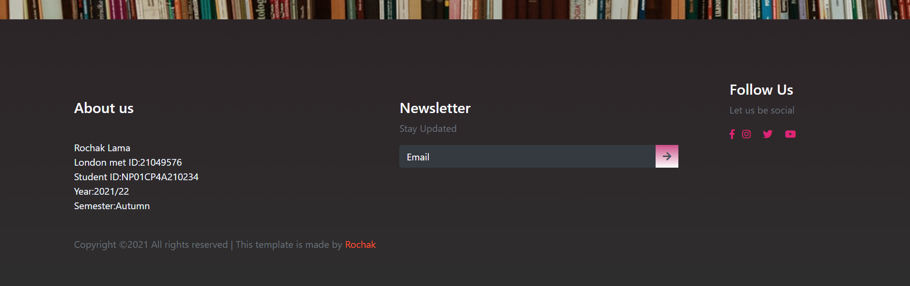

*Figure 35 Contact Us About Us*

# Testing:

1 . Test no 1

|  |  |
| --- | --- |
| Objective | To check if the text is hovering or not. |
| Action | Hovering over text. |
| Expected Result | The text color should change. |
| Actual result | The text color was changed. |
| Test | The test was successful. |



